



Essay / Assignment Title: Designing a sales Tableau Dashboard for a chosen company

Programme title: Visualization and Story Telling using Tableau

Name: EMRE ÖZYÜREK

Year: 2024

CONTENTS

CONTENTS 2
INTRODUCTION 5
1. Target Audience of the Project 5
2. Sales KPIs to Focus on in the Dashboard 5
3. Goals and Expectation 6
PROBLEM IDENTIFICATION 7
1. Scope of the Problem 7
2. Data Analytics and Business Intelligence Solutions 7
3. Transforming Data to Insightful Representation 8
SOLUTION FINDING: 10
1. Review of Data Analytics Tools 10
Data Visualization 10
Dynamic Dashboards 10
Interactive Filters 10
KPI tracking 10
Predictive Analysis 11
Rich Data Integration 11
2. Areas Where Tableau Will Help 11
DASHBOARD DESIGN 13
1.The Best Visualization Methods for Every KPI 13
Income - Area/Bar Charts 13
CTR-Line Chart 15
CPC (Cost per Click)-Line Chart 15
Fill Rate- Line Chart 16
Dual Axis Line Chart for Impressions & Ad Requests 17
2. Illustration of The Schematic of The Predesigned Dashboard 18
a. 3P PLA- Detailed Breakdown -1 Dashboard 18
b.3P PLA- Detailed Breakdown -2 Dashboard 19
c.3P Display - Detailed Breakdown Dashboard 20
3.Color Scheme and Visual Elements 21
Colour Scheme 21
Visual Elements 21
4.The Link To Tableau Public Dashboard 21
DISCUSSION 22
1. Solution Advantages 22
2. Limitations of the Solution 22
3. Suggestions for Further Improvement 23
BIBLIOGRAPHY 25
APPENDIX 26
TABLE OF FIGURES 26

Statement of compliance with academic ethics and the avoidance of plagiarism

I honestly declare that this dissertation is entirely my own work and none of its part has been copied from printed or electronic sources, translated from foreign sources and reproduced from essays of other researchers or students. Wherever I have been based on ideas or other people texts I clearly declare it through the good use of references following academic ethics.
(In the case that is proved that part of the essay does not constitute an original work, but a copy of an already published essay or from another source, the student will be expelled permanently from the postgraduate program).

Name and Surname (Capital letters):

EMRE ÖZYÜREK
Date: 09/10/2024

INTRODUCTION

1. Target Audience of the Project
Target audiences for this project would include: financial analysts of the company-FP&A team, CFO, and maybe a broader group of business leaders. The users are professionals that would like to make strategic decisions based on the monitoring of the Company Advertising Revenues, Performance Trends, and Cost Efficiency.
- Financial Analysts: They are responsible for monitoring the overall financial performance of the firm through advertising revenues and profitability KPI analysis.
- CFO: They are decision makers, interested to see whether advertising spend is in line with revenue and whether financial performance meets the target.
- Top Management: They are managers interested in learning about the contribution that advertising campaigns bring to the whole business strategy and how to optimize costs.

2. Sales KPIs to Focus on in the Dashboard
We will have to focus on the following sales-focused KPIs in this dashboard:
- Ad Revenue: Ad revenue generated through 1P and 3P PLA and Display ad formats need to be analyzed monthly and quarterly.
Example: Monthly and quarterly trends can be clearly noticed on the 3P PLA Revenues chart.
- CPC - this is an important indicator for understanding the cost efficiency of ads. Higher costs affect efficiency.
- CTR: It is, in a nutshell, the effectiveness KPI of an ad. The higher it is, the more interest there is in an ad.
- Ad Requests and Impressions: It gives insights into how the ad requests and impressions trend, the prevalence and reach of ads.
- Fill Rate: The number of ad impressions relative to the impressions requested. In other words, the higher this rate, the better utilised our ad inventory is.
- Effective CPM (eCPM): Cost per 1000 impressions. Shows how much advertising space earns and is an important metric for measuring sales targets.

3. Goals and Expectation
- Revenue Growth: The CFO and financial analysts want to understand the trending of 1P and 3P revenues over quarters and annually. They should be tracking whether the revenue growth is consistent and how revenues are distributed across ad formats.
- Efficiency: How ad spend will match revenue, focusing on the effectiveness of CPC. Higher revenue with lower costs will be targeted, in particular for 3P ads.
- Optimisation of Performance: Financial teams will try to understand which ad format and strategy works better by observing the CTR and fill rates of ads.
- Cost Control: They are going to want to understand if costs are under control through metrics such as CPC and eCPM. Of course, it is about enhancing profitability with ads-especially via these indicators.

PROBLEM IDENTIFICATION

1. Scope of the Problem
In this project, we will largely focus on trend detection and performance analysis. This dashboard assists decision makers in developing data-driven strategies by measuring important indicators of advertising income and overall corporate success. The issue at hand can be summarized under the following headings:
- Advertisement Performance Analysis: Some of the key indicators watched to understand which formats are performing better among 1P and 3P ads include revenue, click-through rate, and cost-performance ratio.
- Trend Finding and Forecasting: The forecast of future revenue trends based on past data, how CTR and CPC will shape. The analysis of how there is a correlation between ad demands, impressions, and revenue data is needed, especially.
- Efficiency and Optimization: A number of strategies need to be understood for the efficient use of the advertising budget, lowering costs per click, and improving fill rates. Because for that, deep analysis is required of many indicators like ad demand or impression balance, fill rate, and eCPM.

2. Data Analytics and Business Intelligence Solutions
Competencies of data analytics that equally fulfill the requirement of business intelligence solutions include the Chief Financial Officer, the Financial Planning and Analysis Team, and so on.
- Dashboards and Reporting: Visualize data for quick and effective comprehension of complex metrics. For example, revenue and cost metrics, click-through rates, and fill rates can be clearly monitored using BI tools like Tableau.
- Trend Analysis: Through the analyses conducted using BI tools based on historical data, the discovery of performance trends is possible, allowing one to make future revenue, CPC, and CTR estimates. By doing so, advertising strategies can be optimized.

- KPI monitoring: The BI solution allows automatic monitoring of the KPIs and their deviation or unexpected trends. Also, since the advertising revenues and costs efficiency are kept under close watch by the CFO and the FP&A team, they are allowed to decide more precisely.
- Performance Optimization: BI tools enable finding underperforming advertising campaigns at a much faster pace. These tools identify various opportunities upon which one can focus for improvement. For example, low fill-rate campaigns can be analyzed very rapidly to understand which segments are in higher demand.

3. Transforming Data to Insightful Representation
The following data transformations and processing steps can be used to represent data in a meaningful and insightful way:
- Time Series Analysis: The organization of data into time series formats shows the changes in advertising revenues, click-through rates, cost per click, and fill rates over time. This will help in spotting trends.
- KPI Calculations: Data transformation needs to be done so that key performance metrics are visualized by calculating KPIs like Fillrate, CTR, CPC, and eCPM.
- eCPM - Cost Per Thousand Effective Impressions: Cost per one thousand effective impressions is what eCPM defines; in Latin, "Mille" means 1,000. Basically, that is the revenue per 1,000 ad impressions. eCPM portrays how efficiently an ad campaign or ad inventory is bringing in money. It helps compare various ad formats or platforms in their efficiency concerning the revenue per impression. Formula: eCPM = Total Revenue / Total Impressions × 1000
- CTR (Click Through Rate): CTR means Click Through Rate, and it refers to the number of people that click an ad after its viewing, the impression of the ad. CTR will tell something about the engagement or relevance to the target audience. If there is a high CPC, that means more people clicked on the ad after it was viewed, usually a sign of good performance of the ad relevance. Formula: CTR = (Total Clicks / Total Impressions) × 100
- CPC - Cost Per Click: This is the price of one click, which can also be the sum a display advertiser pays to secure a single click on his advertisement. In general, CPC is applied in pay-per-click models of advertising. CPC essentially gives them a notion of how much money they really need to earn one click and optimize their ad spend based on their campaign's effectiveness. Formula: CPC = Total Ad Requests / Total Clicks
- Fill Rate: The term for the percentage of ad requests that are resulting in an ad actually showing-up and therefore, an impression. It is a way of measuring how well the underlying Ad Delivery system is working. A low fill rate may indicate that there is not enough ad inventory whereas high fill rates may indicate that most ad requests are being filled with actual ads. Formula: Fill Rate = (Total Impressions / Total Ad Requests) × 100
- Segmentation-Based Analysis: Separating 1P and 3P ad segments to track how each ad format performs separately. It helps us see which ad type generates more revenue, or has a greater click-through rate.
- Data cleaning and normalization: These steps are important step for filling in missing data and inconsistencies, integrating data in a single format from different data sources. At the end of this process, the data will become comparable and reliable.
- Filtering and Drill-Down: In such a way, by turning on filters to only display the amount of data the user needs and/or putting on drills for deeper analysis of metrics in different time cycles, quarterly, monthly, and weekly reviews.
These steps help the chief financial officer and financial analysts make more strategic decisions and take better control of ad performance.

SOLUTION FINDING:

1. Review of Data Analytics Tools
In this project, we aim to effectively present financial analyses and performance indicators for our target audience, especially using Tableau, one of the data analytics tools. Tableau is a very powerful tool in terms of business intelligence and data visualization, and the following features can help us gain insights from our dataset:

Data Visualization
Tableau helps us present our data through understandable graphs and visualizations. Examples include the following: Time series graph: We can trace the development of metrics like revenue, CPC, and CTR over time. This will not be hard to do, for instance, with the graph 3P PLA Revenue. Distribution and trend analyses: We analyze relevant performance indicators-usually CPC and eCPM-over a certain period of time and identify trends and deviations.

Dynamic Dashboards
With Tableau’s dynamic dashboards, we can compare different data segments (e.g. 1P/3P PLA and Display data) on the same panel, and allow users to perform detailed analysis with relevant filters and drill-down features. For example, financial analysts can examine revenue by month and quarter, and also see click-through rates (CTR) and fill rates (Fill Rate).

Interactive Filters
Friendly filtering: Tableau allows users to filter and segment on the dashboard. Our target audience can filter and analyze data by 1P or 3P segments, ad formats (PLA or Display).
For instance, in a situation where there is a need to check only the 3P PLA performance of a campaign, the CFO or financial analyst can focus only on the 3P PLA data through Tableau.

KPI tracking
With Tableau’s KPI tracking features, we can create dashboards that clearly show key performance indicators (CTR, CPC, Revenue, etc.) in our data. These metrics can be tracked in real time, and anomalies and trend deviations can be seen instantly.

With KPI tracking along with color displays: For instance, you can color the CPC values above a threshold or highlight points where revenue falls below a certain level.

Predictive Analysis
Thanks to the predictive analytics available within Tableau, we can look backward at trends within our data and estimate future performance. This can be especially helpful for issues such as ad demands and revenue expectations. Tableau’s “Forecast” and “Trend Line” features are suitable for this type of predictive analysis.
For example, we can make critical decisions in campaign planning by predicting the performance of ad impressions and clicks in the coming months.

Rich Data Integration
Tableau integrates data from a wide range of sources and analyzes it with much ease. We are able to pull data from sources like SQL databases, Excel, Google Analytics, among others, and analyze or process it very fast. This provides a chance to collect information from different sources around our company and visualize it on one single platform.

2. Areas Where Tableau Will Help
Following is a quick summary of the main benefits of how Tableau can help in the process of gaining insights from our dataset:
- Less Data-Intense Reporting: Instead of seeing reports heavy with data, our target audience-CFO and FP&A team-can make better decisions using Tableau insight-heavy graphs and visuals.
- Data-Driven Decision Making: With Tableau's visualization and data analysis capabilities, businesses can make fast yet correct analyses and, therefore, more data-driven decisions. For instance, see low-performing 3P Display campaigns and optimize your costs in an instant.
- Time-Saving Analysis: Since Tableau itself analyzes and visualizes data, financial teams do not have to go through manual reporting and analysis. It not only speeds it up but also reduces human error.
- Performance Optimization: With the help of Tableau, we come to know which campaigns are running poorly or have a high CPC. Thus, we can optimize such campaigns and find opportunities that give better revenue with lesser costs.
- Customizable Dashboards: We can come up with the development of customizable dashboards based on each of their expectations-target audience, financial analyst, CFO, etc. For example, while the CFO focuses more on financial metrics, financial analysts might focus on detailed metrics such as occupancy rate and CTR.

DASHBOARD DESIGN

Next, we'll address which KPIs work well with different kinds of visualizations and which components we should emphasize to create an efficient and user-friendly dashboard design.

1.The Best Visualization Methods for Every KPI
Let's now explore some of the top visualization strategies that might work well with each KPI:

Income - Area/Bar Charts
- Bar Charts: The most effective way to display the quarterly variations in 3P PLA and 3P Display revenues is through bar charts. It would serve as a means for viewing comparative changes from each quarter and then visualizing it easily.
- Area Charts: Area charts are also appropriate for showing ranges of continuous growth and declines in revenue. For example, the 3P PLA Revenue chart is used as an area chart, which is suitable to show general trends of revenue.
  - Benefit: It can make periodic revenue increases and decreases quite clear. It makes trends clear.
  - Disadvantage: It will look complicated if too much data is added in. It is only suitable for trend analysis.4
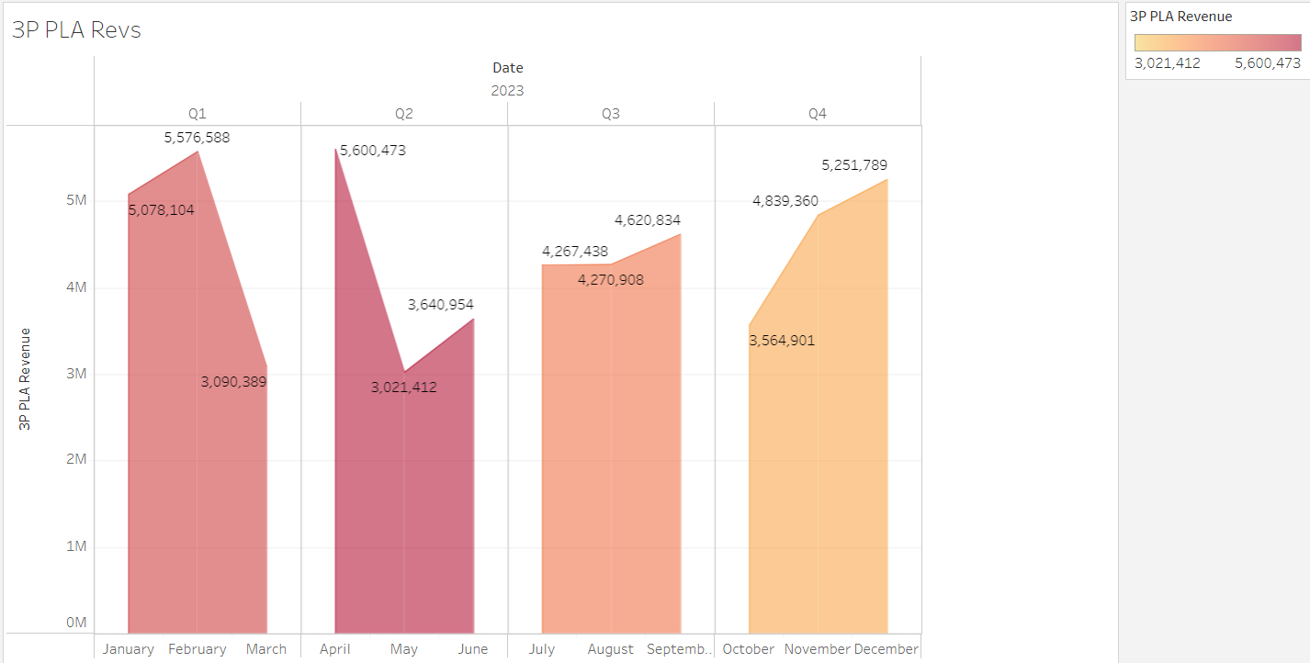
Figure 1
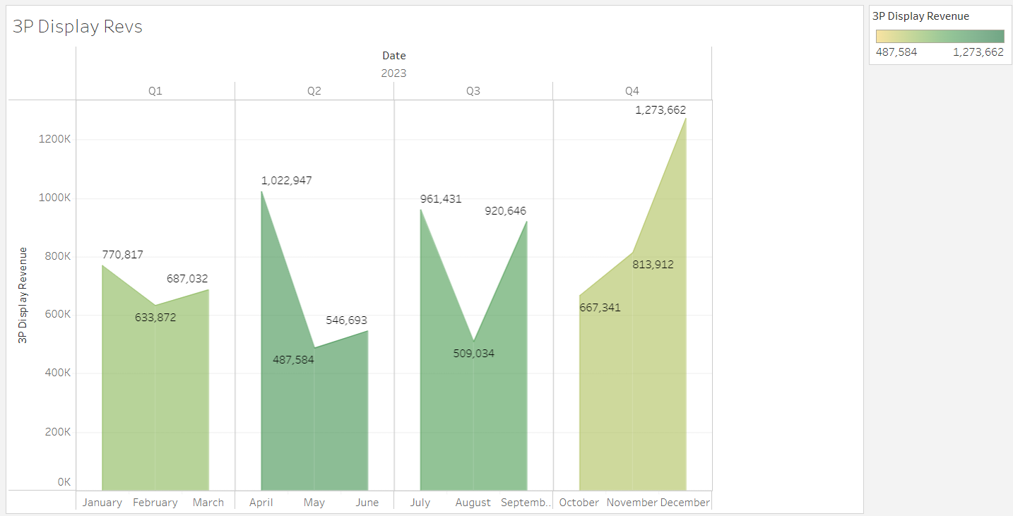
Figure 2

CTR-Line Chart
- Line Chart: Line charts can be used to indicate how CTR changes over time. For example, in order to compare each month's click rate and view its trend, a line chart would perfectly serve the purpose. The chart shows the ups and downs of each click rate very clearly.
  - Benefit: It makes the performance change tracking by the system over time easier. The rises and falls are very clear.
  - Disadvantage: In the case of too much data, the chart may look cluttered. It can also be confusing if there are more variables.
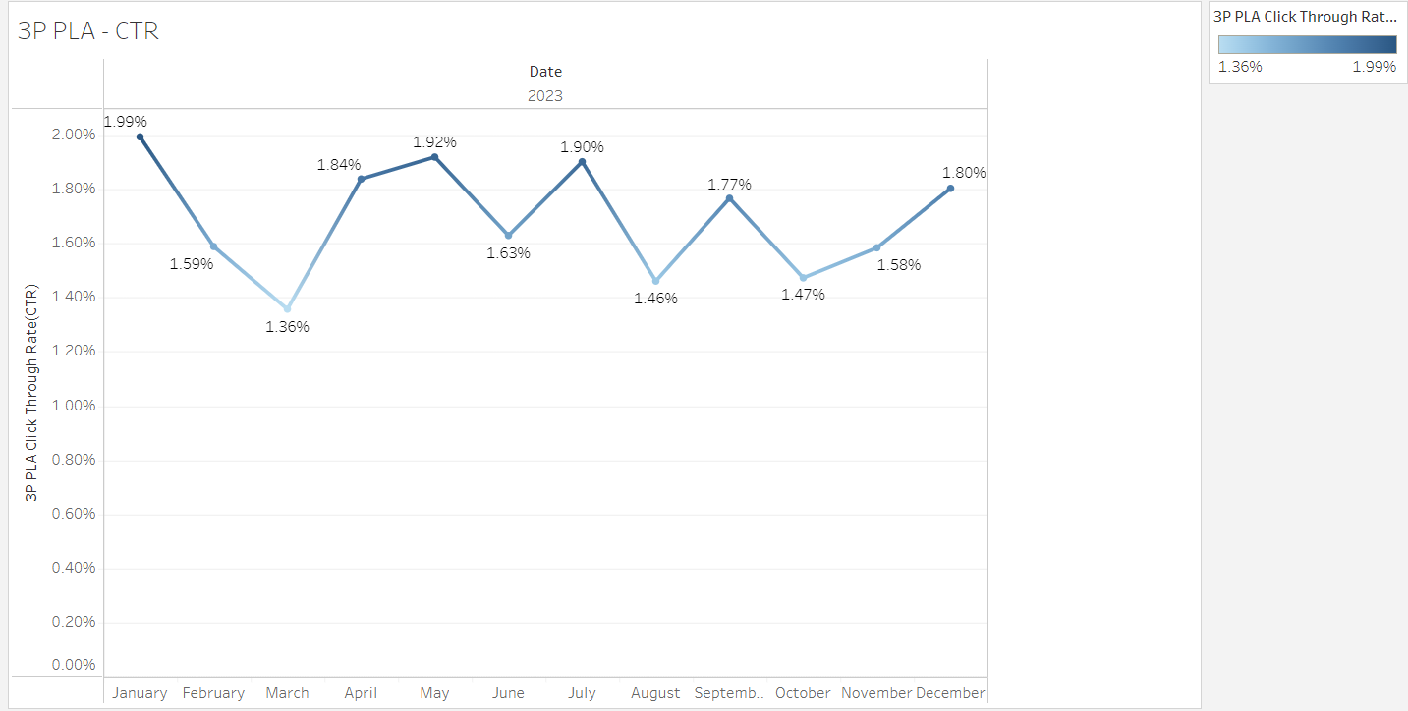
Figure 3

CPC (Cost per Click)-Line Chart
- Line Chart: Fluctuations in CPC can be shown using line charts so that one will be able to know how the cost per click changes within months.
- Benefit: This is one of the most effective methods to represent time series data. It clearly shows the trend and the variance in cost.
- Disadvantage: When applied in the same chart for different KPIs, it creates confusion.
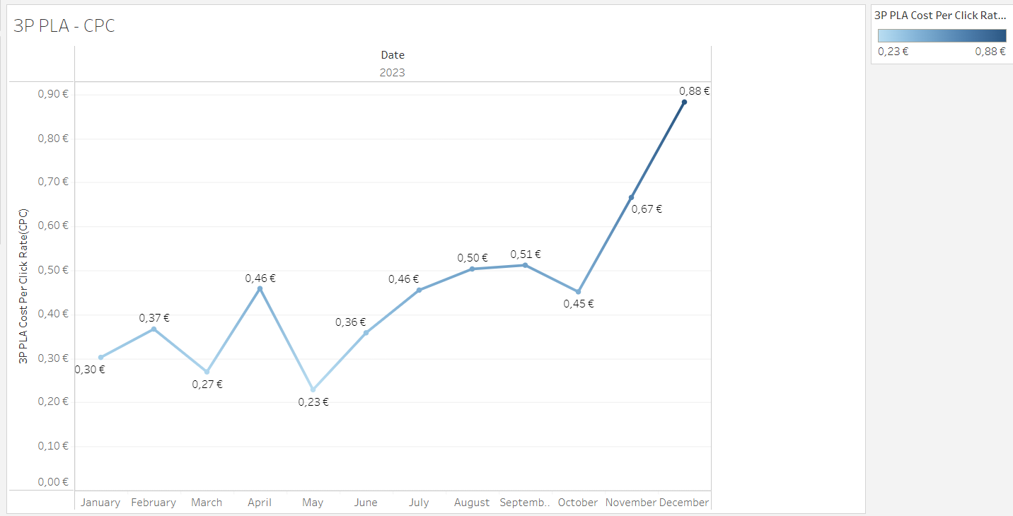
Figure 4

Fill Rate- Line Chart
- Line Chart: Line charts work fine to depict ups and downs of fill rate over time. When we have a very variable data set (for example, peaks and valleys in ad requests), this metric is preferable to a line chart.
- Benefit: Very good at showing daily or monthly performance changes.
- Disadvantage: Can be difficult to track if there are many peaks and valleys.
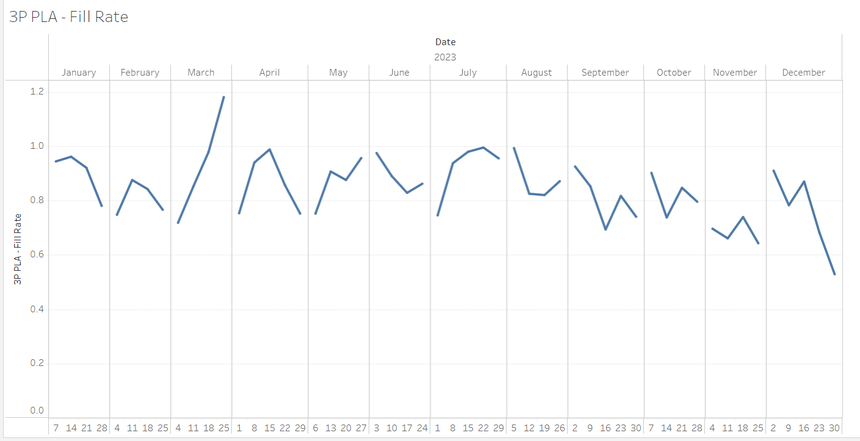
Figure 5

Dual Axis Line Chart for Impressions & Ad Requests
- Dual Axis Line Chart: We could also plot a comparison of both metrics on one chart with dual-axis line charts for ad impressions and requests.
- Benefit: It works really well in showing two diverse but related KPIs within one chart. It clarifies the comparison.
- Disadvantage: It is not very easy to understand if the two metrics are in very different units.
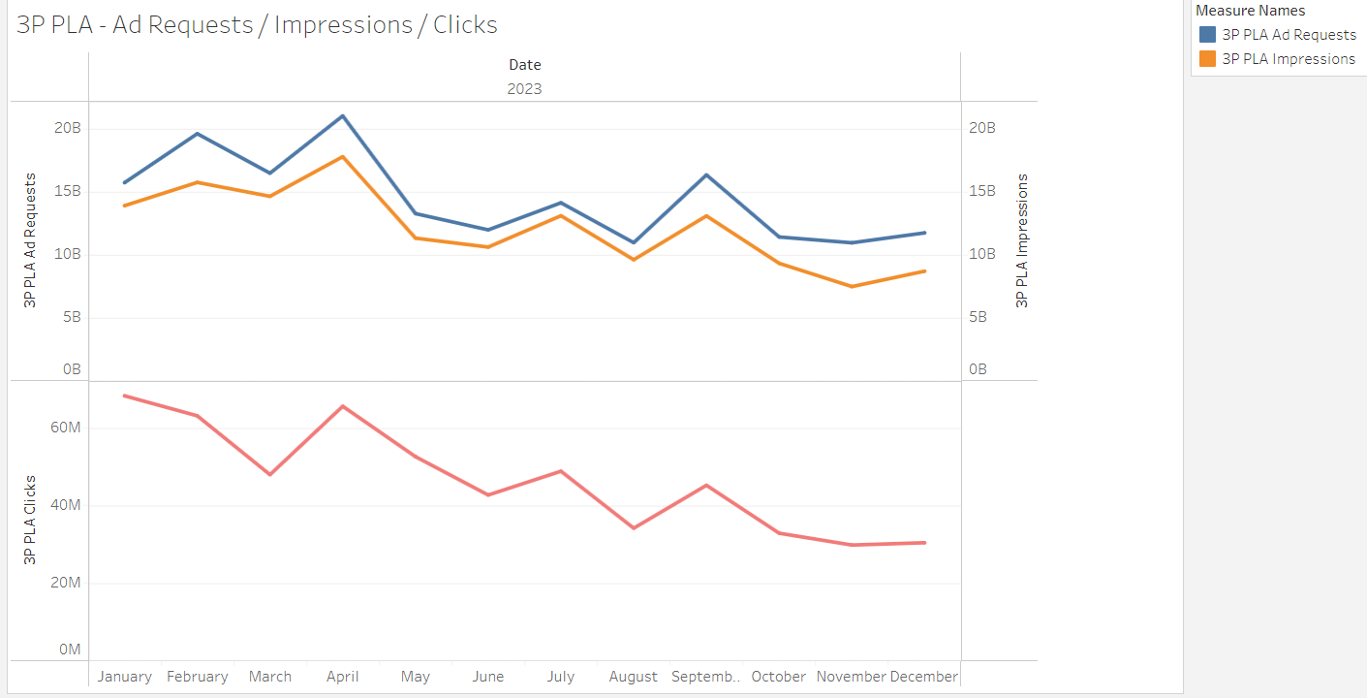
Figure 6

2. Illustration of The Schematic of The Predesigned Dashboard

a. 3P PLA- Detailed Breakdown -1 Dashboard
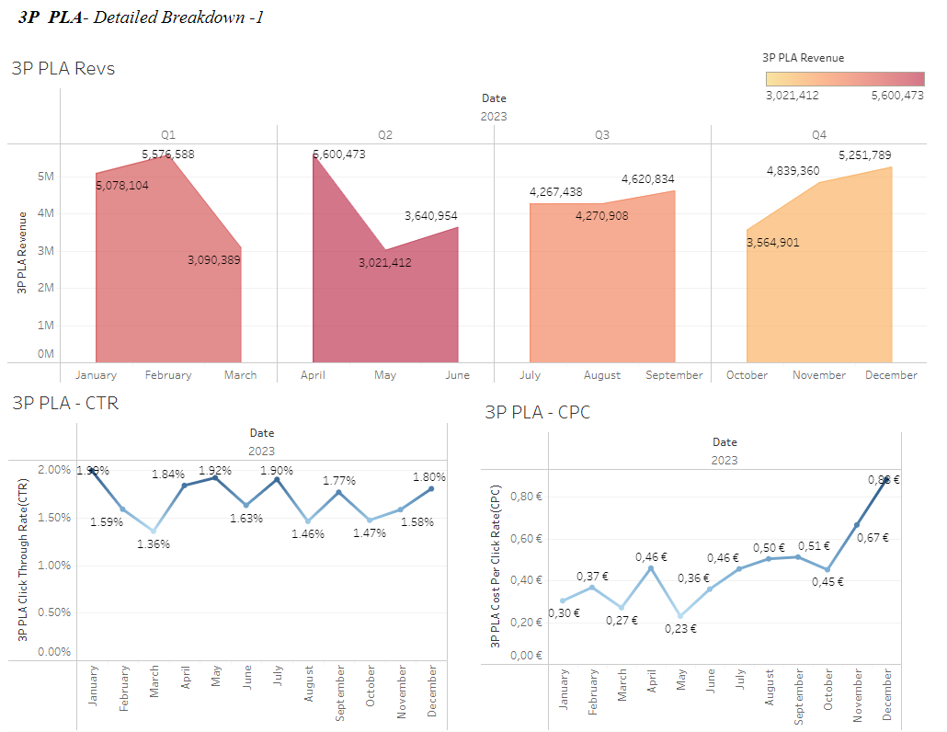
Figure 7. 3P PLA- Detailed Breakdown -1 Dashboard
- Top Section: The revenues have been charted for the quarter-on-quarter change as an area chart for income.
- Bottom Section: The 3 PLA CPC & CTR are visualized by two different line charts based on time series. Comparisons are done by placing them side by side.

b.3P PLA- Detailed Breakdown -2 Dashboard
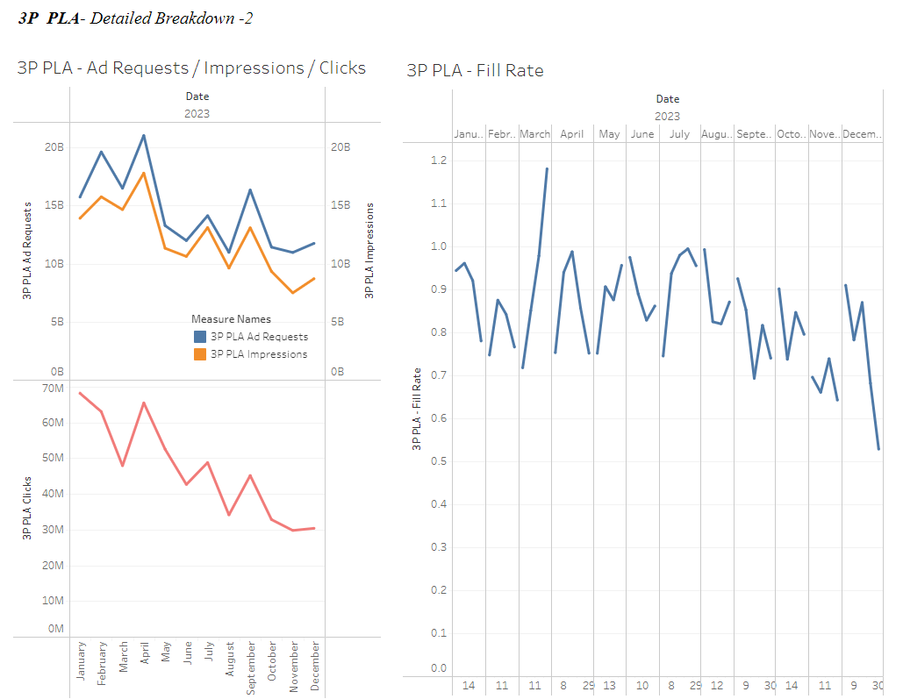
Figure 8. 3P PLA- Detailed Breakdown -2 Dashboard
- Top Section: 3 PLA Impressions and Ad Requests are shown with a dual axis line chart.
- Middle Section: The trend of change in Fill rate over time is middle with a line chart.
- Bottom Section: 3 PLA Clicks are below with a line chart for better comparison.

c.3P Display - Detailed Breakdown Dashboard
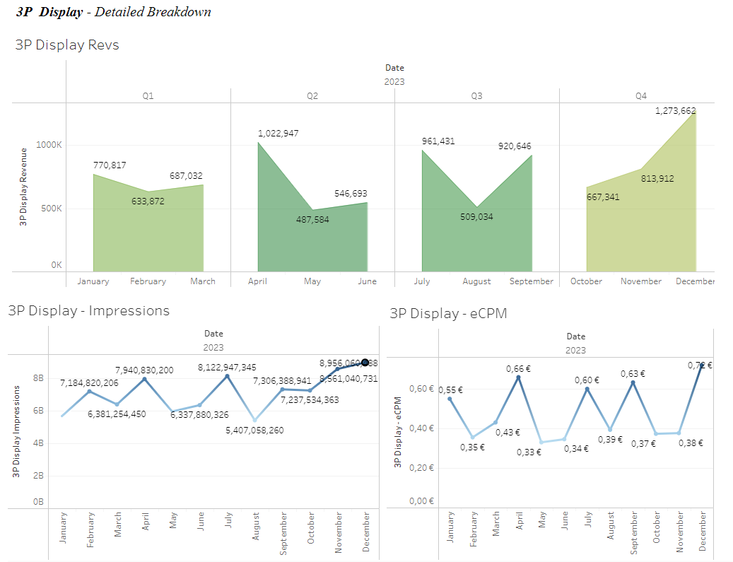
Figure 9. 3P Display - Detailed Breakdown Dashboard
- Top Section: The revenues by quarter are shown to identify changes in the income area chart.
- Bottom Section: 3P Display Impressions & eCPM are visualized by two lines graphs, each representing time series data. Comparisons are enabled by positioning the line graphs side by side.

3.Color Scheme and Visual Elements

Colour Scheme
Colours must make sense and be intuitive. For example:
Warm colours for revenue orange, red: Warm colors can be used for positive KPIs like revenue and growth.
Cool colours for cost blue, grey: Cooler tones are to be used for the cost-related KPIs like CPC.
Neutral colours grey tones: can be used for metrics which don't show very high changes like fill rate or impressions.

Visual Elements
Minimalist Design: The design needs to be minimalist without superfluous graphical details for making interaction better with the user. The free spaces around graphs facilitate an open look to the user.
Accent Colors: Accent colors, such as red and green, are used in highlighting points of much deviation or over-shooting.
Data Labels: All graphs show directly critical data points to the users for the user to grasp information without much effort.

4.The Link To Tableau Public Dashboard
https://public.tableau.com/app/profile/emre.ozyurek/viz/ADVDATA/Sheet1

DISCUSSION

First, in this stage, we are going to review the general performance and user experience of the dashboard by looking into the advantages and limitations of our solution. We will also mention some future opportunities for improvements.

1. Solution Advantages
- Advanced Data Visualization: For example, our dashboard visualizes each KPI; revenue, CTR, CPC, fill rate, impressions, address. Hence, users will be able to track all important metrics on one place. It will consequently turn out to be a huge advantage for financial analysts, CFOs, and other top decision-makers that all important metrics will be congregated here.
- User-Friendly Design: Presentation of data in a clear, understandable, and attractive manner makes it easier for users to interact with it. Using line and bar charts enables the comparison across different time periods in KPIs, making the analysis of trends simpler.
- KPI Relationship: Showing metrics like CPC, CTR, and Requests on the same platform make it easier to show the user how these metrics relate to one another. For example, the direct influence of an increased CPC on CTR can be clearly analyzed.
- Color Scheme and Layout: Selected color scheme and minimalistic design allow the user to perceive information within a fraction of a second. Presenting data in simple terms and not making it overly complex makes information easier to retrieve.

2. Limitations of the Solution
- Data Density: The volume of the data which can be displayed on the Dashboard may be very high. Particularly when big data sets and too many KPIs are followed day by day/month by month, the information that appears in the charts can overwhelm the users. For example, if too many line charts are added to the charts, the latter become complex, which might not be understandable by users.
- Lack of Real-Time Data: The data used on the Dashboard is static data from a certain period. For example, if the company has to make decisions in real-time, then this dashboard needs to be optimized towards the access of up-to-date data. At times, instant data can become highly critical for making financial decisions. Hence, this inadequacy might prove to be serious.
- KPI Depth: Performance indicators in the dashboard are higher-level. Besides that, not all filtering and drill-down functionalities, in terms of a detailed analysis of the data records, will be available to develop a deeper look at each and every KPI. For example, if the CTR tends to lower for some specific quarter, further segmentations will be needed to analyze the cause of this decline in more detail.
- Compatibility with Mobile Devices: Although the screen layout of the dashboard and visualization techniques may be well-set for the desktop, in case it is not fully usable on mobile devices or smaller screens, it may negatively affect the user experience.

3. Suggestions for Further Improvement
- Real-time data integration: More enhancements on our dashboard can be in real time for data. In respect to that, the FP&A team can view ad performance and increases in cost instantly, and through this can make a quick action against it. Indeed, this is possible with the features of BI tools like Tableau, which support real-time data flow.
- Filtering and Drill-Down: More interactivity can be integrated into the Dashboard. Any particular quarter or month can be selected by the user and viewed at a more detailed level. Besides, filtering features can be integrated with which, upon the click, can reach the details of a particular KPI. Examples are customer segmentation and geographic analysis.
- Mobile and Tablet Compatibility: This is a huge enhancement to make the Dashboard more mobile-friendly. Users can easily track KPIs on mobile as well as on desktop. This is going to be very handy for CFOs and senior executives who are always on the move.

- Advanced Predictive Analytics: The Dashboard can add forecasting and projection of trends. For example, machine learning algorithms can be integrated to see how the future rates of CPC or CTR might change based on historical trends. This would perhaps be a good place where Tableau's predictive analytics tools could come into play.
- Comparing Goals: Besides performance tracking of KPIs, the comparison of these metrics against goals can also be inclusions on this dashboard. For example, knowing how much of a revenue target set for a particular month or quarter has been met aids in making strategic

BIBLIOGRAPHY

- Meyer, B.C. and Bishop, D.S. (2022). A lesson in Tableau dashboard design: Playing the beer game with a real‐time data connection. Decision Sciences Journal of Innovative Education. doi:https://doi.org/10.1111/dsji.12264.
- Bach, B., Freeman, E., Abdul-Rahman, A., Turkay, C., Khan, S., Fan, Y. and Chen, M. (2022). Dashboard Design Patterns. IEEE Transactions on Visualization and Computer Graphics, [online] 29(1), pp.1–11. doi:https://doi.org/10.1109/tvcg.2022.3209448. ‌
- Google Books. (2014). Communicating Data with Tableau. [online] Available at: https://books.google.de/books?hl=tr&lr=&id=zoHOAwAAQBAJ&oi=fnd&pg=PR2&dq=tableau+dashboard+design&ots=ab-dvN5B8_&sig=Fu_dUCATFMm-oBDfAyDyzVd5Z8w&redir_esc=y#v=onepage&q=tableau%20dashboard%20design&f=false [Accessed 6 Oct. 2024]. ‌
- Bei, Z. and Gielens, K. (2022). EXPRESS: The One-Party Versus Third-Party Platform Conundrum: How Can Brands Thrive? Journal of Marketing, 87(2), p.002224292211168. doi:https://doi.org/10.1177/00222429221116803.
- Hong, X., Xu, L., Du, P. and Wang, W. (2015). Joint advertising, pricing and collection decisions in a closed-loop supply chain. 167, pp.12–22. doi:https://doi.org/10.1016/j.ijpe.2015.05.001.
- Etro, F. (2021). Product selection in online marketplaces. Journal of Economics & Management Strategy. doi:https://doi.org/10.1111/jems.12428.

APPENDIX

TABLE OF FIGURES
Figure 1 14
Figure 2 14
Figure 3 15
Figure 4 16
Figure 5 16
Figure 6 17
Figure 7. 3P PLA- Detailed Breakdown -1 Dashboard 18
Figure 8. 3P PLA- Detailed Breakdown -2 Dashboard 19
Figure 9. 3P Display - Detailed Breakdown Dashboard 20

